**PROJECT BASED SERVICE**

**“INTRODUCING THE IMMUNE SYSTEM THROUGH GAMES”**



**Group 3 - Grade X**

**DIZA YUSITA SALSABILA**

**FELICIA TIFFANY HERTADA**

**GILANG REZKI SAMUDRA**

**JONATHAN DENVER PURBA**

**MELANY PUTRI MARGANA**

**NURUL KHAIRUNNISA**

**RATU PUTRI DEWI**

**ROSALINE CYNTHIA FINA SITOHANG**

**TARAKA YUMNA SARWOKO**

**TIMOTHY LOUIS BARUS**

**PRADITA DIRGANTARA HIGH SCHOOL**

**BOYOLALI**

**2020**

|  |  |
| --- | --- |
| No Agenda  Diajukan tanggal  Approved |  |

**PROJECT BASED SERVICE**

**TAHUN 2020/2021**

**SMA PRADITA DIRGANTARA**

|  |  |  |  |
| --- | --- | --- | --- |
|  | **NAME OF ACTIVITY** | : | INTRODUCING THE IMMUNE SYSTEM THROUGH GAME |
|  | **CODE** | : | *Nomor Urut/SMAPD-03/III/2020* |
|  | **GROUP** : ***Group 3 / X-A***   * 1. Supervisor 1 : Joko Susilo, M.Sc   2. Supervisor 2 : Widya Yuni Lestari, S.Pd   3. Group Coordinator : Jonathan Denver Purba   4. Vice Coordinator : Timothy Louis Barus   5. Secretary 1 : Ratu Putri Dewi   6. Secretary 2 : Rosaline Cynthia Fina Sitohang   7. Problem Researcher 1 : Gilang Rezki Samudra   8. Problem Researcher 2 : Felicia Tiffany Hertada   9. Theory Researcher 1 : Taraka Yumna Sarwoko   10. Theory Researcher 2 : Diza Yusita Salsabilla   11. Mediator 1 : Melany Putri Margana   12. Mediator 2 : Nurul Khairunnisa | | |
|  | **BACKGROUND :**  According to the critical essay that we have constructed, the lacking quality of human resources in Indonesia is predominantly due to the inadequate interest of the students. As it turns out, the learning method is the main key contributing to this problem. We have formulated the problem and have analyzed several topics in relation to said problem. That analysis prompts us to conclude that, for various reasons, the learning method and education system in Indonesia do not appeal to its students.  Tedious learning methods have become the primary issue that we raise. It should be that, along with the rapid development of technology, the learning method could evolve to be more entertaining and innovative. However, this boom in technology has not been optimized. Additionally, in these COVID-19 pandemic conditions that enforces “Distance Education”, a monotonous learning experience will cause the students to become easily bored. To remedy this, we are endeavouring to consider the opinions and feelings of students alike, and propose a solution to create an ideal condition of education in Indonesia.  In order to alleviate this problem, we conducted this activity; creating an educational, biology-themed online game aimed toward senior high school students. The relatively broad theme of this game will be further focused toward viruses and the subsequent immune responses. Beside its role as a media to introduce new materials in a more enjoyable way, it is also expected that this game will increase students’ knowledge on viruses and how they infiltrate and infect the human body. This knowledge will be useful especially during this pandemic. | | |
| 1. **S** | **AIM :**  The aims of this activity are:   1. Resolving the issue of students’ low interest 2. Heightening cooperation and critical thinking of students 3. Utilizing this globalization era and informatics technology to better the education system 4. Introducing the concept of viral and immune infection to students | | |
|  | **TARGET :**  The objectives of this activity are:   1. Creates learning methods that students like. That is not only is learning fun, but also shapes the character of students 2. Increases interest of student learning in Indonesia, according to our CE study 3. Increases public awareness, particularly high school students’ against viral infections | | |
|  | **PLACE OF EXECUTION:**  This Project Based Service will be implemented entirely online. Starting from the process of drafting, creating, and testing the product on the high school student community. | | |
|  | **CONCEPT OF PROJECT BASED SERVICE :**  According to the results of our Critical Essay entitled **A NEW FACE OF INDONESIAN EDUCATION: FUN LEARNING TO INCREASE LEARNING INTEREST**, group 3 will help alleviate or solve the issue of low student interest in learning activities with the following concepts:  The development of an educational game centered on biological content, namely viruses and the human body’s natural immune responses in relation to viruses. This game would detail the course of the virus as it infects the human body. The game begins with the virus still outside the body, followed by the virus entering and multiplying itself. We also include the role of antibodies and the immunity system in the process of viral infection. We chose SARS-CoV-2 to be the main content of this game, thus realizing our target of increasing public awareness of the coronavirus.  Players will start in an environment occupied by humans. When the game begins, the player as a virus will enter one of the human bodies and select one of the following options; the nose, eyes, or mouth. Players will undergo a series of stages that illustrate the virus’ journey in the respiratory system.  In addition to being a medium for delivering material, this game can also promote positive behaviours to support the formation of students’ characters. Persistence, endurance, patience, friendly competitiveness and cooperation can be developed by playing this game. Moreover, students will better appreciate and admire the intricacies of the human body. With this in mind, we strive to construct the content of this game according to what it should be and not deviating from its scientific origins. We plan to do this by compiling information from various references, both from books and from the internet in an effort to acquire accurate and credible data.  After the game is finished, we will do a test run on fellow high school students and provide a questionnaire to obtain data. We will then analyze this data to see the effectiveness of the game. Following that, we can conclude whether this project meets its predetermined targets. Likewise, this data also plays an important role as a reference point for improving this game in the future. | | |
|  | **EXECUTION SCHEDULE :**  This activity will be executed starting September 2020. Detailed schedule as follows :  a. Preparation : 14 - 19 September 2020   * + 1. The drafting and consolidation of the PBS concept     2. Formation of committee     3. Contacting related parties, in this case, game maker services   b. Implementation : 20 September - 4 October 2020   1. Developing the game 2. Finishing touches and self-testing 3. Game testing on high school communities online 4. Data collecting dan analysis   c. Evaluation : November 2020   1. Internal evaluation 2. Institutional evaluation 3. Announcement of the best three that will be held at Expo (Legacy) | | |
|  | **MECHANISM AND STRUCTURE OF THE ACTIVITY :**  Detailed planning regarding the execution of ….(sesuaikan judul) is as follows:  Preparation Period:   * coordinator alongside all members will hold a *brainstorm meet* through chat about the concept and an overview of this Project Based Service. * All members divide into the committees as approved by the coordinator. * The game concept team creates the outline design, plot, and the content of the game. * Mediator and treasurer will contact menghubungi pihak pembuat game dan menyusun rencana anggaran * Seluruh anggota melakukan pertemuan secara daring bersama pembuat game membahas konsep dan menyesuaikan jadwal.   Implementation Period:   * The game flow and content design team collects data and creates detailed designs for submission to third parties. * The game is created and completed by third parties within a given deadline * All members are guided by the supervisors to try and test the game. * Game revised (if necessary) * Members spread the game link for the high school student community to try, in this case we focused testing on the SMA Pradita Dirgantara high school student community, especially grade 10. * The secretary, assisted by other members, makes a questionnaire on the results of the game experiment * All members with the supervisors analyzed the data that had been collected.   Termination Period/Evaluation   * Internal evaluation (Teachers and students) * Institutional evaluation (Directorate , School, dan Group) * Delivery of the best three that will be held at Expo (Legacy) | | |
|  | **LIST OF REQUIREMENT :**   1. Game concept 2. Game developer 3. Graphic designing apps (Procreate,Adobe Illustrator, and IbisPaint X) 4. Internet quota 5. Google Meet 6. Google Form 7. Google Docs 8. WhatsApp | | |
|  | **EXECUTION COMMITTEE** :    Personnel involved in this activity are as follows*:*   1. Penanggungjawab : Kepala SMA Pradita Dirgantara 2. Consultant : Dr. Sutanto, DEA 3. Supervisor 1 : Joko Susilo, M.Sc 4. Supervisor 2 : Widya Yuni Lestari, S.Pd 5. Coordinator : Jonathan Denver Purba 6. Secretary : Ratu Putri Dewi 7. Treasurer : Felicia Tiffany Hertada 8. Game content designer : Rosaline Cynthia Fina Sitohang 9. Game content designer : Diza Yusita Salsabilla 10. Game content designer : Taraka Yumna Sarwoko 11. Game content designer : Timothy Louis Barus 12. Game content designer : Gilang Rezki Samudra 13. Mediator 1 : Melany Putri Margana 14. Mediator 2 : Nurul Khairunnisa | | |
|  | **BUDGET ALLOCATION :**  According to the detailed activity plan, this activity requires financial support with a sum of Rp 2.450.000, - *(two million four hundred fifty thousand Rupiah)* with the financing details as follows:   1. Game Developer Service (Fatwork.id, Adi Kusuma): Rp1.700.000,- 2. Internet Quota: 15 ✕ Rp 50.000,- | | |
|  | **FOLLOW UP AND SUSTAINABILITY**  The proposed educational game will pose as a media to help develop the learning methods in Indonesia. Following the first version of this game, various features may also be added. For instance multiplayer, competitive mode, added levels, added subjects etc. These additions would be beneficial for shaping student cooperation or enabling them to maintain friendly competition, as well as extending the scope of the game to be more varied in terms of materials and subjects. | | |

Boyolali, November 2020

Group 3

Coordinator/Leader

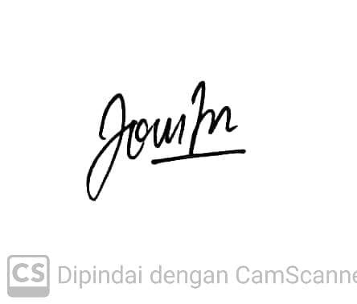

Jonathan Denver Purba

Student Identification Number: ……………

|  |  |
| --- | --- |
| **Mengetahui** :   1. Supervisor 1 :   Joko Susilo, M.Sc  ……………………………………….   1. Supervisor 2 :     Widya Yuni Lestari, S.Pd  ………………………………………. | **Initials of Expert/Consultant :**  Dr. Sutanto, DEA  …………………………………….. |

Approved

Principal

Dr. Yulianto Hadi, M.M

………………………………………………………….

**ATTACHMENT : Project Based Service Mechanism**

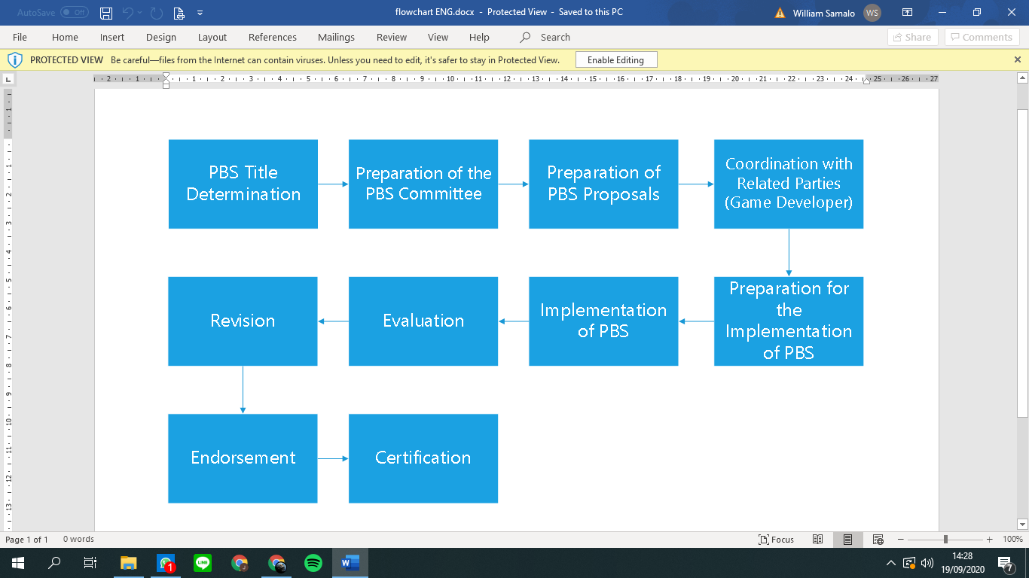

**Attachment : Detailed Budget of PBS Group 3**

|  |  |  |  |  |  |  |  |  |  |  |  |  |  |  |  |  |  |  |  |  |  |  |  |  |  |  |  |  |
| --- | --- | --- | --- | --- | --- | --- | --- | --- | --- | --- | --- | --- | --- | --- | --- | --- | --- | --- | --- | --- | --- | --- | --- | --- | --- | --- | --- | --- |
| **Detailed Budget of PBS Group 3 2020-2021**   |  |  |  |  |  |  |  | | --- | --- | --- | --- | --- | --- | --- | | **No** | **Expense Details** | **Frequency** | **Volume** | **Unit** | **Price** | **Total** | | 1. | Game developer services | 1 | 1 | pcs | Rp1.700.000 | Rp1.700.000 | | 2. | Internet quota | 1 | 15 | pcs | Rp50.000 | Rp750.000 | | Total | | | | | | Rp2.450.000 | |