**CRITICAL ESSAY FOR PROBLEM SOLVING**

**A NEW FACE OF INDONESIAN EDUCATION:**

**FUN LEARNING TO INCREASE LEARNING INTEREST**



**GROUP 3 – GRADE X**

DIZA YUSITA SALSABILA 0046178256

FELICIA TIFFANY HERTADA 0043325670

GILANG REZKI SAMUDRA 0047231801

JONATHAN DENVER PURBA 0041041565

MELANY PUTRI MARGANA 0047776582

NURUL KHAIRUNNISA 0048363820

RATU PUTRI DEWI 0050531312

ROSALINE CYNTHIA FINA SITOHANG 0052868029

TARAKA YUMNA SARWOKO 0050653866

TIMOTHY LOUIS BARUS 0059507071

**PRADITA DIRGANTARA HIGHSCHOOL**

**BOYOLALI**

2020

**TITLE PAGE**

**CRITICAL ESSAY FOR PROBLEM SOLVING**

**A NEW FACE OF INDONESIAN EDUCATION:**

**FUN LEARNING TO INCREASE LEARNING INTEREST**



**GROUP 3 – X GRADE**

**PRADITA DIRGANTARA HIGHSCHOOL**

**BOYOLALI**

2020

**VALIDATION**

Critical essay

**A NEW FACE OF INDONESIAN EDUCATION:**

**FUN LEARNING TO INCREASE LEARNING INTEREST**

**Arranged by Group 3 – X Grade**

DIZA YUSITA SALSABILA 0046178256

FELICIA TIFFANY HERTADA 0043325670

GILANG REZKI SAMUDRA 0047231801

JONATHAN DENVER PURBA 0041041565

MELANY PUTRI MARGANA 0047776582

NURUL KHAIRUNNISA 0048363820

RATU PUTRI DEWI 0050531312

ROSALINE CYNTHIA FINA SITOHANG 0052868029

TARAKA YUMNA SARWOKO 0050653866

TIMOTHY LOUIS BARUS 0059507071

2020

Supervisor 2

**Widya Yuni Lestari, S.Pd**

Supervisor 1

**Joko Susilo, M.Sc**

Principal

**Dr.YuliantoHadi, M.M**

Supervisor 1

**Joko Susilo, M.Sc**

Supervisor 1

**Joko Susilo, M.Sc**

Supervisor 1

**Joko Susilo, M.Sc**

Supervisor

**Joko Susilo, M.Sc**

**DECLARATION OF AUTHENTICITY**

We declare our critical essay, entitled

**A NEW FACE OF INDONESIAN EDUCATION:**

**FUN LEARNING TO INCREASE LEARNING INTEREST**

This work is made by us, group three, and does not include work by other than ourselves,

with the omission being the references mentioned in the bibliography.

We hereby make this statement with full responsibility, and if proven that we have violated this statement, we will accept the consequences given.

Coordinator of group 3



**Jonathan Denver Purba**

0041041565

**DEDICATION PAGE**

**We dedicate this essay to:**

All students in Indonesia who are the main actors of this country's education. They who at the forefront of Indonesia's development to become a developed country. Also for parents who have high hopes for their children. Hope to be proud of with glorious achievements. Hope that the person he loves can shine in the world.

**MOTTO**

“Stay away from negative people, they have a problem for every solution.”

-Albert Einstein

“Success is the sum of small efforts, repeated day in and day out.”

-Robert Collier

“You don’t have to be great to start, but you have to start to be great.”

-Zig Ziglar

“The harder you work for something, the greater you’ll feel when you achieve it.”

-Anonymous

“Kalau orang lain bisa kenapa saya tidak?”

-Jonathan Denver Purba

“Siapa yang bersungguh-sungguh akan berhasil.”

-Ahmad Fuadi

“Jika kamu tidak sanggup menahan lelahnya belajar, maka kamu harus sanggup menahan perihnya kebodohan.”

-Imam Syafi’i

**FOREWORD**

*There will always be an awareness of weakness. However, movement can never happen without an impulse from the heart. Those who are ready to go first, will support all burdens, open new paths and look for gaps between spaces to reach the light.*

First of all, we convey our praise and gratitude to God Almighty. Without His blessing and permission, the preparation of this critical essay manuscript would never have occurred. In composing this essay, we have faced many issues. Most definitely, considering the ten of us have never before met face to face, the struggle in forming and following directions, the ambiguity of orders given, the difficulty of attaining candid information and the often clashing of point of views are no longer foreign to us.

This essay represents our hope for a more advanced education in this country. Indonesia is rich with young intellects ready to act as the face of their beloved homeland. When likened to a gadget, the youth of Indonesia have a capable, strong hardware. Thus, a more innovative program in a dynamically developing era will surely produce more sophisticated devices that are better prepared to perform the multitude of tasks present in this ever-moving age.

However, this essay would not have come to fruition without the assistance of others. Therefore, we foremost would like to express our utmost appreciation and gratitude to everyone involved in the development of information technology. If not for their efforts, we would not be able to compile this essay in online conditions .We would not forget, of course, to extend our thanks to Mr. Joko and Ms. Widya for supporting and aiding us throughout this journey along with Ms. Zeni and Mr. Panji, who have meticulously arranged this format and have directed us in writing this essay.

Perhaps the experience and sense of alignment we have as students have been the keys to forming the idea for this essay, and we have strived to compose it as best as possible. Nevertheless, we are aware of the many flaws within this essay, and we hope to do better on our next CE projects.

**TABLE OF CONTENT**

**COVER PAGE i**

**TITLE PAGE ii**

**VALIDATION iii**

**DECLARATION OF AUTHENTICITY iv**

**DEDICATION PAGE v**

**MOTTO vi**

**FOREWORD vii**

**TABLE OF CONTENT viii**

**PICTURE LIST x**

**CHAPTER I. PRELIMINARY 1**

I.1 Background 1

I.2 Problem Formulation 2

I.3 The Scope of Research 2

I.4 Methods and Approaches 3

I.5 Order 3

I.6 Goal 4

I.7 Benefits 4

**CHAPTER II. BASIS OF THEORY AND FRAMEWORK 5**

II.1 Theories 5

II.2 Framework of Thinking 8

II.3 Hypothesis 10

**CHAPTER III. DISCUSSION 10**

III.1 Actual Condition 10

III.2 Ideal Condition 11

III.3 Analysis Level 13

III.3.A Incompetent educators 13

III.3.B An Education system that is fixated on value standards 14

III.3.C Unpopular learning methods 15

III.4 Problem Solving Identification 15

III.5 Analysis Level 2 16

III.5.A Oppurtunities and obstacles 18

**CHAPTER IV. CLOSING 20**

IV.1 Conclusion 20

IV.2 Advice 20

**BIBLIOGRAPHY**

**CRITICAL ESSAY COMPOSER NAME LIST**

**LIST OF PICTURE**

1. Pie Chart 1 - Responden’s answer about innovation in Indonesian education

2. Pie Chart 2 - Responden’s choice of educational method.

3. Pie Chart 3 - Responden’s choice of subjects.

**CHAPTER I.**

**PRELIMINARY**

**I.1 Background**

The setback of teaching methods in Indonesia when compared to developed countries is truly jarring. This is evidenced by the decline in student interest and enthusiasm for learning. Students are one of the crucial actors in education, and that includes us, the students that compiled this essay. Our own personal experience as students led us to believe that, currently,  the learning and teaching system in Indonesia is somewhat lacking.

The main problems that we raise are monotonous learning methods that subsequently dull a student’s enthusiasm to acquire knowledge. This statement is supported by existing facts that state more than 60% of elementary, junior high and high school students who took our questionnaire views the learning in Indonesia to be tedious and needing innovation. As it should, the development of technology overtime should bring forth an education system that is both more ingenious and fun. Furthermore, if the implementation of online learning in this  COVID-19 pandemic were monotonous and uninteresting, it would quickly bore students.

The government, considered to have not yet committed wholly to advancing education in this nation, often adopts curriculums from other countries. This led to disputes among students who think that our education should also follow Finland with its short study hours and long breaks. This is further boosted by the fact that the ranking of Indonesia's education worldwide is getting worse. Of the 79 assessed countries in the triennial 2018 OECD Program for International Student Assessment (PISA), Indonesia ranked 73rd in Mathematics, 24th in reading and 71st in Science.

Thereby with this essay and project, our group will attempt to appoint the feelings of students and provide a solution to actualize the expected ideal conditions for Indonesia’s education to enhance the quality of our country’s human resources, who are ready to take part in the global field.

**I.2 Problem Formulation**

         The description of the background that has been mentioned leads us to determine the formulation of the existing problem. There are 2 main issues to be discussed in this essay, namely

* 1. The low quality of education in Indonesia

The quality of education is the key to a country's success in developing its human resources. There are a lot of conversations between students about what a good and advanced education really looks like. The government in the education sector in Indonesia has adopted many of the education systems from various developed countries. However, what is being discussed is that if the Indonesian education system has followed developed countries, why are the human resources in this country experiencing a setback in their interest in learning? With this in mind, we want to raise this issue to convey the voice of students to the wider community.

* 1. Advances in technology and globalization as a potential for developing learning methods.

The more time passes, the more globalization and technological developments are improving. We see that technological advances and globalization can be a potential for developing our learning methods. Therefore, we decided to bring forth this topic which will eventually lead us to solve the problem itself.

**I.3 The Scope of Research**

            This research is limited to a monotonous education system and a lack of innovation that causes a decline in student learning intentions in Indonesia. This results in the low quality of domestic human resources. The assessment of the quality of education in Indonesia is taken from a questionnaire that we have distributed prior to composing this essay. The questionnaire was given to students ranging from elementary to high school levels. There is no limit on the responses to fill out the questionnaire.

**I.4 Methods and Approaches**

This essay is prepared by presenting qualitative and quantitative data. In addition to quantitative data in the form of graphics collected by questionnaires through online questionnaires and theoretical descriptions of the literature studies that have been carried out, the authors also pour thoughts stemming from personal experience by placing themselves as figures directly related to the subject matter that we have determined.

We collected data through questionnaires from 23 August 2020 to 3 September 2020. Questions in the form of a questionnaire were given to high school, elementary and junior high school students. We conducted this questionnaire with the intention to obtain candid data from educational actors, that being the students themselves. Apart from that, we also plan to dedicate this essay to channel students' voices that are rarely given thought by the general public. Literature study is certainly needed in order to give considerable weight to this essay. According to the predetermined subject matter, our search for data is about education in Indonesia, its learning methods and the policies that regulate education in Indonesia.

**I.5 Order**

This critical essay is arranged in the following order:

CHAPTER I          : Foreword

The foreword contains the background, problem formulation, scope, objectives and benefits, as well as the methods and approaches in the preparation of this essay.

CHAPTER II         : Theoretical review

In this chapter, we describe the theories that form the main foundation of writing this essay.

CHAPTER III        : Discussion

This section contains our description of the actual and ideal conditions of the subject matter based on the theoretical studies that we have compiled. The analysis we undertake is also described in this chapter, which will then lead to the problem solving.

CHAPTER IV       : Closing

Contains the essence of the discussion and analysis that we have done. Realistic suggestions will also be presented in this chapter.

**I.6 Goal**

Education is the main method in developing the quality of human resources. Thus, students' low interest in learning serves as a problem that must be rooted. Due to the awareness and desire for change, the author aims to put forth an innovative idea as a possible way to remedy this problem. This is done in order to support Indonesia in producing qualified human resources that can compete globally and furthen national development.

**I.7 Benefits**

         This essay will direct the attention of a broader scope of people to the importance of developing an innovative and fun way of learning for students. This will also implore the  government to carry out large-scale studies and updates concerning education in Indonesia, as well as channeling the enthusiasm between students and fostering an important mindset in society, that students, in a certain way, have the power to do big things that have a broad impact.

**CHAPTER II.**

**BASIS OF THEORY AND FRAMEWORK**

**II.1 Theories**

Based on the problems written in the previous chapter, we have determined the main problem, namely the unpleasant learning which causes a decrease in student dedication to learning, which correlates with the deterioration of the quality of human resources in Indonesia. There are 3 theories that underlie our research and form the foundation for the preparation of this essay. The theories are as follows

1. Quality of Education in Indonesia

Education is a means to educate the nation's life in order to form superior human resources capable of advancing the country. According to Article 1 of UU no. 20 of 2003 concerning the National Education System, education is a conscious and planned effort to create an atmosphere of learning and the learning process so that students can actively develop their potential to have religious spiritual strength, self-control, an upstanding personality, intelligence, a noble character and develop the skills needed in society, state and nationwide. Unfortunately, the quality of education in Indonesia is quite inferior when compared to other countries. Based on the United Nations Educational, Scientific and Cultural Organization (UNESCO), in 2000, data on the Human Development Index ranking, Indonesia was in the 109th place in 1999. Meanwhile, according to PISA (Program for International Student Assessment), Indonesia was in 69th position out of 76 PISA survey participants.

When viewed from the data above, Indonesia has a relatively low quality of education. Compared with the countries of the Association of Southeast Asian Nations (ASEAN), Indonesia occupies the 5th rank, behind Thailand, Malaysia, Brunei Darussalam and Singapore (UNESCO 2017). When contrasted to the Finnish education system - the country renowned for having one of the best education systems in the world - Indonesia is certainly no match for it. Education in Finland puts forward the principle of equality between students. In addition, learning hours in Finland are relatively short, only around 30 hours / week with fewer tasks and focus on problem solving methods. Meanwhile in Indonesia, the education system is characterized by competition. The learning hours are also vastly greater, around 40 hours / week, and are reliant on textbooks as well as overwhelming amounts of assignments, both of which are always a mandatory agenda. This very striking difference in the learning system is what causes the quality of Indonesia's education to be much lower than other countries such as Finland.

1. The Influence of Globalization and Technology Development on Indonesian Education

In general, globalization is a process of global society that knows no boundaries. Edison A. Jamli (2005) states that the globalization process takes place in two dimensions, namely the dimensions of space and the dimension of time. Globalization takes place in all fields, particularly in education. Information and communication technology is a major supporting factor in globalization. Due to the existence of information and communication technology, students have access to all the information present on the internet, therefore globalization cannot be separated and avoided, especially in the field of education.

The development of education in Indonesia cannot be parted from the influence of globalization, where science and technology are developing rapidly. Technological advances due to the rapid flow of globalization have the potential to, and have already started to change the pattern of teaching in the world of education. Classical methods of teaching have turned into teaching established upon new technologies such as the internet and gadgets. If in the past, teachers still used a chalk and chalkboard, with globalization underway, teachers now use computers, LCDs, and the internet. Another effect of the development of globalization is that the internet makes things very remarkably convenient and fast. When students get assignments from their teachers, they can easily complete it with the help of the internet, thus able to copy and paste their assignments without understanding the material and concept of the assignment. This results in low quality graduates, as they are not used to thinking critically and searching for information from a source other than the internet.

1. Learning Methods in Indonesia

In general, the learning method is the method chosen by educators in delivering material to students to optimize the teaching and learning process. According to M. Sobri Sutikno (2009), learning methods are ways of presenting subject matter carried out by educators so that the learning process occurred in students in order to achieve goals. There are several kinds of learning methods, including the lecture method, the discussion learning method, the demonstration method, the plus lecture method, the recitation learning method, the experimental method, the field trip method, the training method, the design method, the debate method, the cooperative script method, and the mind mapping learning method. Each of these learning methods has its advantages and disadvantages and the application is conditional.

In Indonesia itself, actually all of these learning methods have been applied in teaching and learning activities. However, education observer Mohammad Abduhzen, at the commemoration of Hardiknas on May 2, Saturday (2/5/2020) considered that Indonesian education was too rigid, bureaucratic and as lack of meaning. This is due to the current learning system is too fixated on standards, on the target curriculum, deprived of meaning, and is probably less pragmatic. In addition, behaviours such as “there is no day without homework”, “do not make a fuss when studying”and “those who cannot solve questions will be punished”, create a rigid and boring class atmosphere (Purnawanto, 2011). Those learning activities cause student enthusiasm for learning to decline and have an impact on the quality of education in Indonesia.

With the rapid development of the internet and advances in information technology, many new learning methods are possible to be developed. It has been shown that according to experts the learning methods in Indonesia are too rigid and fixated on standards. These ways of learning are disliked by students. They could not find the pleasure in the learning process.

**II.2 Framework of Thinking**

In developing this critical essay, first, we conducted brainstorming to determine the topic that we would carry out. Based on that, we came up with topic of the less innovative learning system in Indonesia causing student’s lack of interest to learn. Afterwards, we have built the problem formulation of this topic, namely the learning system that students did not like, the student’s low interest in learning and the low quality of Indonesian human resources. To support our problem formulation, we conducted literature review. Based on the theory that we found, a learning system that was too rigid and monotonous caused a decrease in student interest in learning, which eventually affected the quality of education in Indonesia. In addition, in the current globalization era, Indonesia have not been optimally utilize technology in the learning activities.

Based on the findings of the literature review, we proposed a learning method that could increase student interest in learning through educational games. With these games, it is expected that students would not easily get bored and keen to learn. The game that we planned to develop is an educational game design based on biology lessons. Why did we choose biology? It stemmed from the current situation of a covid-19 virus pandemic in Indonesia particularly the immune system. Therefore we hope that with this game, students can learn biology in a more fun way while protecting themselves from exposure of the covid-19 virus.

Here is the Flowchart of our framework of thinking:

Perumusan masalah

Metode pembelajaran di Indonesia

Peran perkembangan teknologi pada pendidikan

Problem solved

Identifikasi problem solving

Terbelakangnya pendidikan Indonesia

Pembelajaran yang tidak disukai

Rendahnya minat belajar

Rendahnya kualitas SDM

**II.3 Hypothesis**

The low quality of education in Indonesia is caused by several factors, including the use of learning methods that tend to be rigid and monotonous, the lack of innovation in learning and the use of technology that has not been maximized, and the curriculum or education system that is ineffective and burdensome for students. This refers to a decrease in student interest in learning. The decline in student interest in learning causes the quality of Indonesian education to also below. With these conditions, it is not surprising that the quality of human resources in Indonesia is still low. Therefore, innovation is needed in the world of education, in which case it is necessary to further optimize the use of existing technology for the creation of superior quality human resources.

**CHAPTER III**

**DISCUSSION**

**III.1 Actual conditions**

 Education is the key to the success of advancing a nation. Children as the future generation receiving a better education will become the leaders that could push forward a nation. According to Article 1 of UU no. 20 of 2003 concerning the National Education System, education is a conscious and planned effort to create an atmosphere of learning and the learning process so that students actively develop their potential to have religious spiritual strength, self-control, personality, intelligence, noble character, and the skills they need to develop their society, state and nation. The description above showed that there is a reciprocal relationship between students and the state. In order to achieve that, the state, in this case the government, must provide educators and a good education system for the children of the nation. Hence one day they can lead the movement in Indonesia to become a developed country. However there were several barriers.

The first barrier was the existing teaching staff were not competent. In fact, the chairman of PB PGRI, Dudung Nurullah Koswara, said that there were no more than 30% teachers passed the competency examination for teachers (UKG) with eighty points. This condition was also observed in school principals. The UKG test in 2017 was not even among elementary, middle, and high school teachers who got an average of 80 points. The second barrier was the school facilities. Based on the data we found, the completeness of public school facilities is lower than that of private schools, so that instead of public schools being the examples, private schools were actually being the role models. Finally it turned out that the education system presented by the government did not take into account the interest of students in learning.

Globalization bringing unlimited access to information may serve as a double edged sword. One side globalization provide unlimited source of information for learning. On the other hand, globalization also give access to other enjoyable and interesting things than learning. In modern times, the magnitude of globalization has affected a large part of society, including students. Students found the other side of globalization more appeasing. Most of them have even believed that education is unimportant. Therefore we consider that the education system and learning methods in Indonesia did not attract students.

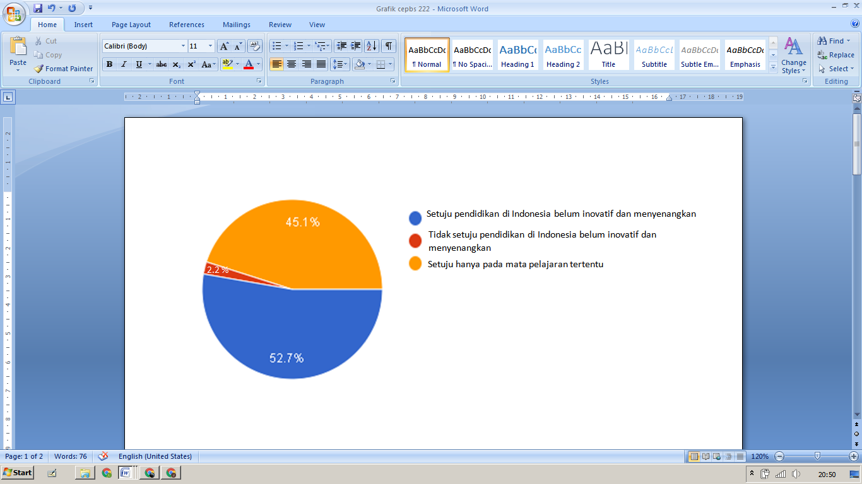

Picture 1 Pie Chart from questionnaire – Responden’s answer about innovation in Indonesian education

We have conducted a survey using a questionnaire. The result was  that the education system in Indonesia was unpleasant and required innovation or renewal. Of the 126 respondents who participated in our survey, 64 agreed that education in Indonesia was not fun, 57 people agreed, but only on certain subjects, and the remaining 5 people disagreed that education in Indonesia was not fun and needed innovation. Of 126 students, more than 95% of them believed that Indonesian education system warranted innovation.

**III.2 Ideal Conditions**

Good quality education can produce good human resources too. In this case, all countries, including Indonesia, have the same goal through the existence of educational programs. As stated in Article 1 of UU no. 20 of 2003 concerning the National Education System, Education is a conscious and planned effort to create an atmosphere of learning and the learning process so that students actively develop their potential to have religious spiritual strength, self-control, personality, intelligence, noble character, and the skills they need, society, nation and state.

This law indirectly describes the nation's expectation to have superior human resources, especially in the presence of education. In other countries, such as Finland, Japan, Singapore, and even Malaysia, which incidentally are still allied with the Indonesian nation, this hope has shown its realization. This can be proven by surveys and research conducted by PISA and UNESCO, where the quality of education in Indonesia is still below these countries.

In Finland, being a teacher is considered more difficult than being a doctor or a lawyer. As stated by Sari Muhonen, a music teacher of all levels in Finland, in his research entitled *'In Finland, It's Easier to Become A Doctor or Lawyer than A Teacher - Here's Why'*. In his work, he reveals, "It is more difficult to get into the University of Helsinki teacher education program (acceptance rate 6.8 percent) than the law program (acceptance rate 8.3%) or medical program (acceptance rate 7.3 percent) at 2016, ”and,“ In Finland, teachers are trusted, valued and educated in advanced degree programs. Becoming a teacher starts with getting a placement in one of the highly selective teacher education programs. I vividly remember the two educational books I had to study for the first part of the Finnish early grade teacher education entrance exam. The books looked different - much more difficult to read - than the reading I read months earlier for the Finnish secondary school matriculation exam. "These data prove that the quality of teachers in Finland is no joke, so it can generate learners or resources. quality human resources too.

So, according to the author's view, the ideal condition of the education system in Indonesia is where students and teachers can develop their own passions which should be implemented from an early age, of course with the support of the government. For example in Japan, the education system is centered on three bases, namely formal education in schools which certainly does not burden students with a pile of assignments and compulsory subjects, moral education at home, and community education. Even though the curriculum is similar to that of Indonesia, the system is more advanced and more friendly to education practitioners in Japan. There, students are given the right to choose the desired subjects starting from junior high school, almost similar to the lecture system in Indonesia. In fact, this system can produce human resources who have self-control, personality, intelligence, noble character, and skills needed by themselves, the community, the nation and the state, in accordance with the expectations of the nation in UU No.20 of 2003 Article 1 earlier.

According to kompasiana.com news reviews, what is meant by ideal education is one that meets several criteria, such as age-appropriate education, according to the capacity of students' ability to receive, and education that is given in stages and gradually. The Indonesian education system should be more "friendly".

Then, the internet and information technology continued to develop. This also had a major impact on the education sector. Where IT plays a role in developing student learning methods. The following is the application of information technology in education:

1. Source of teaching materials
2. Learning infrastructure
3. Information resources
4. Enable long-distance interaction

The number of benefits and existing applications makes informatics skills a basic ability and competency for students to be able to achieve progress in the world of education.

**III.3 Analysis Level 1**

From the actual and ideal conditions in sub-chapters A and B above, the authors can analyze the existence of a significant gap between the two conditions. What we analyzed are.

1. **Incompetent educators**

The reality of teaching employment in Indonesia is inadequate, especially in designing learning, research, and also mastery of foreign languages. Even though the teaching staff is the foremost element that determines a nation. To become a developed nation, competent educators are needed. This will ensure the improvement of the quality of human resources in Indonesia, but it is not an exaggeration to say that teachers must have extraordinary competence. The difference between the two conditions above requires a careful and helpful solution to overcome the teacher competency problem.

There are 4 competencies that teachers must meet to be able to teach, namely pedagogic, professional, personality, and social. The data we obtain states that of the 3.9 million teachers in Indonesia, 25% of them have not met academic qualifications as teachers, and 52% of teachers also do not have professional certificates. With simple logic and thinking, how can education give birth to superior human resources if the majority of the teaching staff do not meet the competence as teachers?

This is important to note, considering that teaching is a profession that is desired by many people. The government, in this case, must increase the qualifications in admitting prospective teachers.

1. **An education system that is fixated on value standards.**

The current education system in Indonesia, which is still fixated on passing standards, is ineffective and it is burdensome for students. Students who are forced to understand all subjects, take multiple exams and complete their homework every day certainly have no pleasure in the learning process. Learning which is only based on the obligation to complete the task and the acquisition of grades will never be effective. Students tend to quickly forget the material presented by the teacher.

What is even more worrying is that the main purpose of education to create moral, good-natured and intelligent people does not materialize. "You’re clever in mathematics, but you can't even throw garbage in the place," said Aher in his speech while attending the inauguration of the West Java provincial education council at Gedung Sate on March 5 2018. This expression explains the large deficiencies in the education system in Indonesia.

Developed countries such as Japan and Finland are said to have succeeded in building their education systems well. Japan prioritizes the education system with passion from an early age, which allows students to focus on developing their talents and interests. Then Finland, which has short study hours and collaborative learning, emphasizes the physical and mental health of its students. However, with this short learning, good human resources were produced.

1. **Unpopular learning methods.**

The facts in the field show that the learning methods in Indonesia are monotonous and ineffective. How come? It has been a long time since teaching in Indonesia has only revolved around reading books, asking questions, submitting opinions, then testing. This learning method is what students consider to be boring learning. The popular term among students is *memorize-test-forget*.

Learning methods should be made as fun and interesting as possible. So that students get their own experience in the learning process and the material being studied can be remembered and understood easily.

In the current era, where the advancement of information technology is developing very rapidly, learning methods should also be updated. Materials that were previously only included in student study books in long texts, can now be visualized by programming. Not only is it made into a 2-dimensional model, now we can even make 3D modeling using certain software. So that the material being taught can attract students and develop their interest in learning. Such is the effect of technological progress and globalization on education.

But facts say otherwise. The emergence of the internet and gadgets has actually become an obstacle for students in their learning. There have been many reports of students addicted to gadgets. Many things from gadgets and the internet are the cause of addiction. Online games and social media are two things that trigger gadget addiction.

**III.4 Problem Solving Identification**

Learning methods that are fun and not monotonous can attract students' interest in learning. Also a friendlier and more effective education system will bring better education in Indonesia. Then it will end with an increase in the quality of domestic human resources. To increase students' interest in learning, appropriate and accurate solutions are needed. So that the concept of solution given does not generate new problems.

The author gets 3 possible problem solving concepts to do. That is

1. Educational game development as a fun learning medium.
2. Reform of a more "friendly" education system.
3. Increasing teacher competence by tightening teacher acceptance.

**III.5 Analysis Level 2**

We choose educational game development as a fun learning medium, as the main concept for solving this problem.

The bad effects of globalization and advances in information technology as described in the Actual Conditions are certainly an obstacle and one of the root causes of decreased student interest in learning. However, with a simple logic of thinking, making us propose this concept as the main problem solving concept. If students are addicted to online games, then we only need to make educational games as a medium for delivering material. With a concept that is interesting and liked by students, of course it will make them feel new experiences in the learning process.

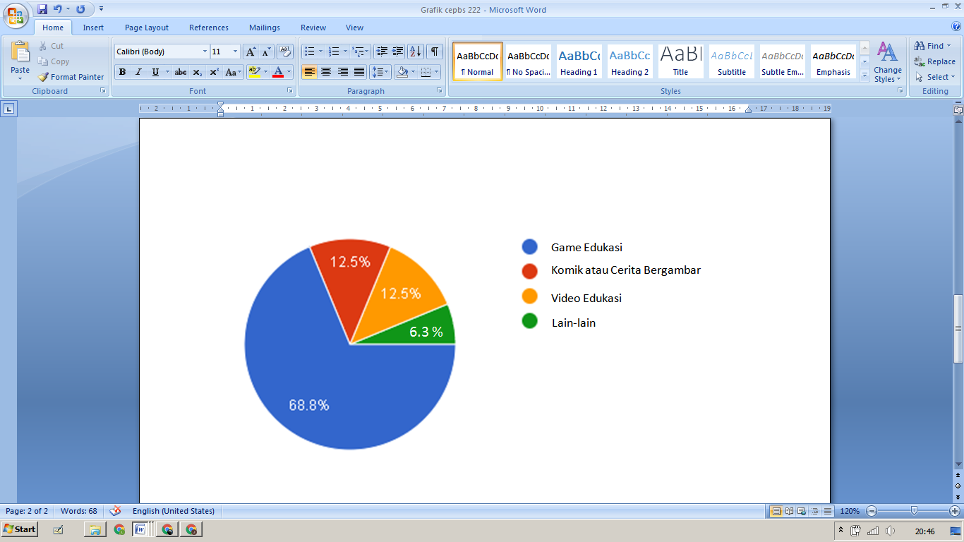

Picture 2 Pie Chart from questionnaire – Responden’s choice of educational method.

Of the 126 people who followed the questionnaire we conducted, 81 people chose educational games to be interesting and fun learning media. Other respondents, totaling 29, chose comics or pictorial stories, and the rest chose movies or videos as media for delivering more interesting material.

In the questionnaire, we also asked questions about suitable genres to be included in the game. The answers to the game genres given by the respondents varied widely. Game genres such as adventure, board game, and even battle royale are the most frequently asked. On the other hand, respondents who chose pictorial stories submitted their opinions about the genre of the story. The ones most frequently asked are action, adventure, sci-fi, and slice of life fiction stories.

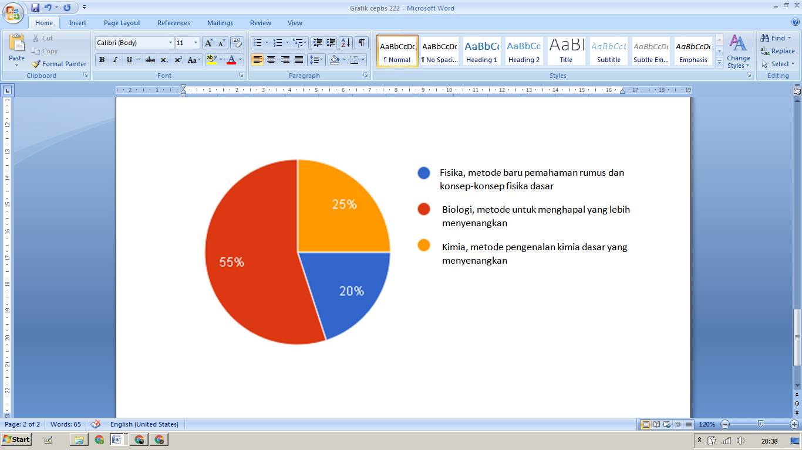

Picture 3 Pie Chart from questionnaire – Responden’s choice of subjects.

In addition to genres, we also provide multiple choice questions that contain material in science that will greatly facilitate student understanding. Of the 126 respondents, 51 chose biology, 43 chose physics and the rest chose chemistry. This data is in line with our hopes and goals. We plan to make an educational game that contains biological material in it. The human body's immune system is the main material we want to include in this game. Since this essay was written at the time of the COVID-19 pandemic, we hope that this game can also increase students' insight into virus attacks.

**III.5.A Opportunities and obstacles**

The opportunities and constraints that we have summarized are as follows

1. Opportunity
2. The number of students, especially teenagers, who like to play games. This is an opportunity because students will find it easier to move to familiar educational games. So that the possibility of applying educational games is greater. In addition to providing knowledge, this can also be a solution to reduce the number of students who are addicted to non-educational games.
3. The availability of many software that supports both 2D and 3D modeling games. Game creation software in Indonesia is quite capable. In fact, there are many ways that are offered for game creation. Apart from software, there are human resources to create games in Indonesia. However, they are underappreciated in Indonesia. Therefore, if the making of educational games is developed, this can play a role in reducing the number of unemployed in Indonesia.
4. It will be easy to like because the visualized material will be easier for students to understand. The fun way is certainly preferable to the ordinary and monotonous. With a fun way of learning, the brain will tend to remember learning over a longer period of time. This is certainly something that students, teachers and education expect.
5. Multiple platforms that make it easier to spread the game. Various information is disseminated in such a fast time. The following advantages are of course an opportunity for the spread of this learning method. Information on educational games can be spread more quickly and widely to students in various places. In addition, educational games can more easily convey the latest and latest knowledge.
6. Obstacles
7. Ownership of gadgets and internet access capabilities are not evenly distributed in Indonesia. This is the main obstacle of educational games. Various areas in remote areas of Indonesia are still not being reached by technological developments. There are also many areas that still maintain traditional culture and resist development. This will hamper the spread of educational games aimed at advancing education in Indonesia. For the educational game method to work, students in Indonesia must have been reached by technology.
8. It is possible to cause eye damage due to the use of gadgets. Gadgets are devices that produce light that can interfere with eye health. This device is actually not eye damage. However, prolonged use of gadgets can have long-term adverse effects on the eyes. Too long looking at gadgets can cause tension and fatigue which has a negative impact on the eyes. Furthermore, the light generated by the gadget is the most harmful light to the retina. Continuous exposure to this light will also make the cornea and lens of the eye powerless to block or reflect light back. Apart from the eyes, the light from this gadget can disrupt the human sleep cycle.

**BAB IV**

**CLOSING**

**1V.1 CONCLUSION**

The analysis that has been done leads us to draw a conclusion. That low interest in learning makes Indonesia have poor human resources. The low interest in learning is apparently caused by students' dislike of the learning methods used by teachers and the education system in Indonesia itself. Where this learning method is considered unpleasant and less innovative in the times with advances in information technology.

**IV.2 ADVICE**

The first advice we can give is to all students in Indonesia. As actors of education in Indonesia, let us understand the important role that we must play for this nation. In order to advance our nation, we must become educated and superior human beings. Therefore interest in learning must be increased. In the current era, with technological advances and the very fast flow of globalization, we must avoid external obstacles such as gadget addiction. Don't be complacent.

We also want to suggest that the government listens more to the voices of students. Set up a cutting-edge and effective education system that doesn't overwhelm students. It also increases competency for teachers, because understanding of the material is also determined by the learning methods used by the teacher. The preparation of the curriculum in the future must pay more attention to the impact on the condition and health of students, both physically and mentally.

Information technology has advanced rapidly. With that, teachers can create or develop new learning methods that are more fun and preferred by students. Monotone delivery of material can be presented with different visualizations, which is more interesting, of course, for students.

The development of learning methods and the delivery of material can be carried out into various things, ranging from illustrated stories or comics, educational games, to animated videos containing the material to be taught. Seeing the field conditions where many students like to play games on their gadgets, we plan to make an educational game with the theme of biology about the human immune system, considering that at the time this essay was compiled Indonesia was still in a state of emergency COVID-19. We hope that this learning method can attract students' interest again.

**Bibliography**

Law of Education

<<http://luk.staff.ugm.ac.id/atur/UU20-2003Sisdiknas.pdf>>

Media Mahasiswa Indonesia. 2020. *Rendahnya Kualitas Pendidikan*. Accessed on 2 September, 2020.

<<https://mahasiswaindonesia.id/rendahnya-kualitas-pendidikan/>>

Dian, Erdiana. 2017. *Introspeksi! Inilah Peringkat Pendidikan Indonesia di Dunia*. Accessed on 2 September, 2020.

<<http://dianerdiana.blogspot.com/2017/05/introspeksi-inilah-peringkat-pendidikan.html>>

Leonard. 2015. “Kompetensi Tenaga Pendidik di Indonesia” *Analisis Dampak Rendahnya Kualitas SDM Guru dan Solusinya*. 5(3): 192-201. Accessed on 2 September, 2020.

<<https://media.neliti.com/media/publications/234977-kompetensi-tenaga-pendidik-di-indonesia-6403e904.pdf>>

Kalbin, Salim. 2014. *Pengaruh Globalisasi Terhadap Dunia Pendidikan*. Accessed on 3 September, 2020.

<<https://www.researchgate.net/publication/271205216_PENGARUH_GLOBALISASI_TERHADAP_DUNIA_PENDIDIKAN_Oleh>>

Leni, Marianti. 2018. *Dampak Globalisasi Terhadap Pendidikan*. Accessed on 3 September, 2020.

<<https://www.kompasiana.com/len/56ded30d779773896f5aaa40/dampak-globalisasi-terhadap-pendidikan>>

Zonareferensi.com. 2020. *Pengertian Metode Pembelajaran Menurut Para Ahli dan Secara Umum*. Accessed on 3 September, 2020.

<<https://www.zonareferensi.com/pengertian-metode-pembelajaran/>>

Nofantoro. 2020. *12 Macam Metode Pendidikan Pembelajaran Beserta Penjelasannya*. Madeblog.com. Accessed on 3 September, 2020.

<<https://made-blog.com/metode-pembelajaran/#gsc.tab=0>>

Retia, Kartika Dewi. 2020. *Saat Pendidikan di Indonesia Dinilai Kaku dan Hampa Makna*. KOMPAS.com. Accessed on 3 September, 2020.

<<https://www.kompas.com/tren/read/2020/05/03/092800965/saat-sistem-pendidikan-di-indonesia-dinilai-kaku-dan-hampa-makna?page=all>>

Purwoko, Haryadi Santoso. 2012. “Pengaruh Suasana Kelas yang Monoton dan Membosankan terhadap Proses Pembelajaran” *calon guru fisika blog*. Accessed on 3 September, 2020.

<<https://calongurufisika.blogspot.com/2012/08/pengaruh-suasana-kelas-yang-monoton-dan.html?m=1>>

Lucky, M. 2019. *70 Persen Guru di Indonesia Tidak Kompeten*. Galamedia.com. Accessed on 4 September, 2020.

<<https://galamedia-pikiran--rakyat-com.cdn.ampproject.org/v/s/galamedia.pikiran-rakyat.com/news/amp/pr-35544419/70-persen-guru-di-indonesia-tidak-kompeten?amp_js_v=a3&amp_gsa=1&usqp=mq331AQFKAGwASA%3D#aoh=15993192726862&referrer=https%3A%2F%2Fwww.google.com&amp_tf=Dari%20%251%24s&ampshare=https%3A%2F%2Fgalamedia.pikiran-rakyat.com%2Fnews%2Fpr-35544419%2F70-persen-guru-di-indonesia-tidak-kompeten>>

Educational Statistic of 2018. Badan Pusat Statistic. Accessed on 4 September, 2020.

<<https://www.bps.go.id/publication/2018/12/06/a65b526c119ce8f799e5ea63/statistik-pendidikan-2018.html>>

Esti, Arnini. 2019. *Minat Belajar Peserta Didik dalam Proses Pembelajaran*. Jurnalistiwa.co.id. Accessed on 4 September, 2020.

<<https://www.jurnalistiwa.co.id/2019/01/minat-belajar-peserta-didik-dalam.html>>

Arie, Lukihardianti. 2018. *Aher Sebut Pendidikan di Indonesia Memberatkan Murid*. Republika.co.id. Accessed on 4 September, 2020.

<<https://republika.co.id/berita/p53yjg368/aher-sebut-pendidikan-di-indonesia-memberatkan-murid>>

Japanesestation.com. 2014. *Seperti Apa Sistem Kurikulum Pendidikan Jepang? Yuk, Lihat Bersama!*. Accessed on 5 September, 2020.

<<https://japanesestation.com/lifestyle/japan-fact/seperti-apa-sistem-kurikulum-pendidikan-di-jepang-yuk-lihat-bersama>>

Application of IT in Education by Baktikominfo.id. 2018. Accessed on 5 September, 2020.

<<https://www.baktikominfo.id/en/informasi/pengetahuan/peranan_teknologi_informasi_dan_komunikasi_di_bidang_pendidikan-681>>

The Importance of IT in 21th Century. Koranbogor.com. 2019. Accessed on 5 September, 2020.

<<http://koranbogor.com/berita/hukum/pentingnya-pemanfaatan-teknologi-informasi-di-sekolah-dasar-pada-abad-21-%EF%BB%BF/>>

Putri, Syafiila. 2018. *PEMBELAJARAN YANG MONOTON*. Accessed on 5 September, 2020.

<<https://putrisyafiiladaffafauzany.wordpress.com/2018/09/25/pembelajaran-yang-monoton/#:~:text=Pembelajaran%20monoton%20juga%20merupakan%20pembelajaran,membuat%20proses%20pembelajaran%20tidak%20baik>.>

**CRITICAL ESSAY COMPOSER NAME LIST**

Name : Jonathan Denver Purba

Position in Group : Group Coordinator

Date of Birth : Jakarta, 13 April 2004

Origin : Bogor, West Java

NISN : 0041041565

Class : XA

Presence Number : 13

Name : Timothy Louis Barus

Position in Group : Vice Coordinator

Date of Birth : Jakarta, 28 February 2005

Origin : Jakarta

NISN : 0059507071

Class : XA

Presence Number : 28

Name : Ratu Putri Dewi

Position in Group : Secretary 1

Date of Birth : Yogyakarta, 27 January 2005

Origin : Yogyakarta

NISN : 0050531312

Class : XA

Presence Number : 24

Name : Rosaline Cynthia Fina Sitohang

Position in Group : Secretary 2

Date of Birth : Jakarta, 18 November 2005

Origin : Jakarta

NISN : 0052868029

Class : XA

Presence Number : 26

Name : Gilang Rezki Samudra

Position in Group : Problem Statement Search Team

Date of Birth : Batam, 01 Desember 2004

Origin : Batam, Kepulauan Riau

NISN : 0047231801

Class : XA

Presence Number : 11

Name : Felicia Tiffany Hertada

Position in Group : Problem Statement Search Team

Date of Birth : Yogyakarta, 04 Oktober 2004

Origin : Yogyakarta

NISN : 0043325670

Class : XA

Presence Number : 08

Name : Diza Yusita Salsabilla

Position in Group : Basic Theory Search Team

Date of Birth : Malang, 21 November 2004

Origin : Malang

NISN : 0046178256

class : XA

presence Number : 06

Name: Taraka Yumna Sarwoko

Position in Group: Basic Theory Search Team

Date of Birth: Pontianak, 3 February 2005

Origin: Pontianak

NISN: 0050653866

Class: XA

Presence Number: 27

Name : Melany Putri Margana

Position in Group : Mediator 1

Date of Birth : Boyolali, 21 September 2004

Origin : Boyolali

NISN : 0047776582

Class : XA

Presence Number : 17

Name : Nurul Khairunnisa

Position in Group : Mediator 2

Date of Birth : Surakarta, 27 Desember 2004

Origin : Yogyakarta, Special Region of Yogyakarta

NISN : 0048363820

Class : XA

Presence Number : 20