

**PROJECT BASED SERVICE REPORT**

**“INTRODUCING THE IMMUNE SYSTEM THROUGH GAMES”**



**Group 3 - Grade X**

**DIZA YUSITA SALSABILA**

**FELICIA TIFFANY HERTADA**

**GILANG REZKI SAMUDRA**

**JONATHAN DENVER PURBA**

**MELANY PUTRI MARGANA**

**NURUL KHAIRUNNISA**

**RATU PUTRI DEWI**

**ROSALINE CYNTHIA FINA SITOHANG**

**TARAKA YUMNA SARWOKO**

**TIMOTHY LOUIS BARUS**

**PRADITA DIRGANTARA HIGH SCHOOL**

**BOYOLALI**

**2020**

|  |  |
| --- | --- |
| Agenda no.  Submission date  Approval by admin |  |

**ACTIVITY COMPLETION REPORT**

**SMA PRADITA DIRGANTARA**

**2020/2021**

|  |  |  |  |
| --- | --- | --- | --- |
|  | **NAME OF ACTIVITY** | : | INTRODUCING IMMUNE SYSTEM THROUGH GAMES |
|  | **CODE** | : | *No urut/SMAPD-03/III/2020* |
|  | **GROUP**   * 1. Supervisor 1   2. Supervisor 2   3. Group Coordinator   4. Vice Coordinator   5. Secretary 1   6. Secretary 2   7. Problem Researcher 1   8. Problem Researcher 2   9. Theory Researcher 1   10. Theory Researcher 2   11. Mediator 1   12. Mediator 2 | :  :  :  :  :  :  :  :  :  :  :  :  : | ***Group 3/XA***  Joko Susilo, M.Sc  Widya Yuni Lestari, S.Pd  Jonathan Denver Purba  Timothy Louis Barus  Ratu Putri Dewi  Rosaline Cynthia Fina Sitohang  Felicia Tiffany Hertada  Taraka Yumna Sarwoko  Diza Yusita Salsabilla  Gilang Rezki Samudra  Melany Putri Margana  Nurul Khairunnisa |
|  | **REALIZATION OF FUNDS** | : | 1. Amount of funds : **Rp2.000.000,00**   *(Read: Two Million Rupiah)\**   1. Source of funds : Internal (Collective) |
|  | **BACKGROUND:**  According to the critical essay that we have constructed, the lacking quality of human resources in Indonesia is predominantly due to the inadequate interest of the students. As it turns out, the learning method is the main key contributing to this problem. We have formulated the problem and have analyzed several topics in relation to said problem. That analysis prompts us to conclude that, for various reasons, the learning method and education system in Indonesia do not appeal to its students.    Tedious learning methods have become the primary issue that we raise. It should be that, along with the rapid development of technology, the learning method could evolve to be more entertaining and innovative. However, this boom in technology has not been optimized. Additionally, in these COVID-19 pandemic conditions that enforces “Distance Education”, a monotonous learning experience will cause the students to become easily bored. To remedy this, we are endeavouring to consider the opinions and feelings of students alike, and propose a solution to create an ideal condition of education in Indonesia.    In order to alleviate this problem, we conducted this activity; creating an educational, biology-themed online game aimed toward senior high school students. The relatively broad theme of this game will be further focused toward viruses and the subsequent immune responses. Beside its role as a media to introduce new materials in a more enjoyable way, it is also expected that this game will increase students’ knowledge on viruses and how they infiltrate and infect the human body. This knowledge will be useful especially during this pandemic. | | |
| 1. **S** | **AIM:**  The aims of this activity are:   1. Helping to resolving the issue of students’ low interest 2. Heightening critical thinking and morals of students 3. Utilizing this globalization era and informatics technology to better the education system 4. Introducing the concept of viral infection and immune responses to students | | |
|  | **TARGET:**  The objectives of this activity are:   1. Develop a supplementary learning method to boost the interest of students in learning, 2. Shape students’ characters 3. Increases awareness against viral infections and the body’s immune responses towards pathogens, particularly towards the SARS-Cov-2 virus. | | |
|  | **PARTICIPANTS:**  The game “Coviland” was tested on the high school community via online methods.  The participants of this trial run are as follows :   * SMA Pradita Dirgantara, Boyolali 30 persons * SMA Negeri 1 Mataram 2 persons * SMA Negeri 1 Yogyakarta 1 person * SMA Negeri 9 Malang 1 person * SMA Negeri 2 Taruna Bhayangkara Jawa Timur 1 person * SMP Negeri 4 Yogyakarta 1 person * SMA Negeri 4 Semarang 1 person * SMA Negeri 8 Yogyakarta 1 person * SMA Angkasa 2 Jakarta 1 person | | |
|  | **TIME AND PLACE:**  Time : 6 November, 2020  Place : In participants’ respective places (online) | | |

|  |  |
| --- | --- |
| **10.** | **ACTIVITY MECHANISM & STRUCTURE:**  The activity mechanism and structure are as follows : |

|  |  |
| --- | --- |
| **11.** | **BUDGET ALLOCATION:**  The budgeting details are as follows :  Game Developer Services = **Rp 2.000.000,00** |
| **12.** | **PERSONNEL AND PERSON IN CHARGE:**   1. Person in charge : Head of SMA Pradita Dirgantara 2. Supervisor 1 : Joko Susilo, M.Sc 3. Supervisor 2 : Widya Yuni Lestari, S.Pd 4. Coordinator : Jonathan Denver Purba 5. Secretary : Ratu Putri Dewi 6. Treasurer : Felicia Tiffany Hertada 7. Game content designer : Rosaline Cynthia Fina Sitohang 8. Game content designer : Diza Yusita Salsabilla 9. Game content designer : Taraka Yumna Sarwoko 10. Game content designer : Timothy Louis Barus 11. Game content designer : Gilang Rezki Samudra 12. Mediator 1 : Melany Putri Margana 13. Mediator 2 : Nurul Khairunnisa |
| **13.** | **RESULT:**  The end result of this activity is the educational game “Coviland”. Coviland may be accessed via the link below.  <http://bit.ly/FileCoviland> |
| **14.** | **EVALUATION:**  Respondents wanted a brief guideline on how to play the game, as well as additions of music and sound effects in order to make the game more comfortable and fun to play. We initially wanted to include these additional aspects, however the limited time available resulted in us not being able to incorporate checkpoints, sound effects, and initial instructions regarding the gameplay.  For most of the respondents, the game itself was too difficult and the duration too long, thus, the presence of in-game checkpoints is highly desirable. When developing the game, we focused our attention to players’ character development. Therefore, we created the game to be quite difficult in order to implement the growth of certain characteristics of the students, namely patience and hard work. That being said, respondents' satisfaction in playing this game must also be considered.  Our main goal is to make a game as a means of delivering material. According to respondents’ feedback on our survey, this goal has been fulfilled. However, some felt that the information provided in our game’s “Library” is still too lengthy. Thus, we believe that an adjustment on the length of information given in our game’s “Library” is needed. |
| **15.** | **RECOMMENDATION:**    It is our hope that this program will continue to be conducted as this program advances students’ critical thinking skills and problem solving skills. These skills will be beneficial not only for the individual future of these students, but also to build a more developed Indonesia. From our observations, we have concluded that there are some groups that will take less time than others to complete their project, and some groups need more time than others because of the content of their CE-PBS project itself. During this pandemic situation, every activity is implemented online. This has a negative impact on the group’s overall communication line that may result in a group’s less than optimal performance. With this in mind, we believe that groups should be given a longer time frame to complete their CE-PBS. |

Boyolali, 6 November 2020

Group 3

Group coordinator



Jonathan Denver Purba

Student Identification Number: 20031061

|  |  |
| --- | --- |
| **Knowing** :   1. Supervisor 1 :   Joko Susilo, M.Sc  ……………………………………….   1. Supervisor 2 :   Widya Yuni Lestari, S.Pd  ………………………………………. | **Expert/Consultant :**  Dr. Sutanto, DEA  …………………………………….. |

Approved

Principal

Dr. Yulianto Hadi, M.M

………………………………………………………….

**ATTACHMENT 1. ACTIVITY DOCUMENTATION**

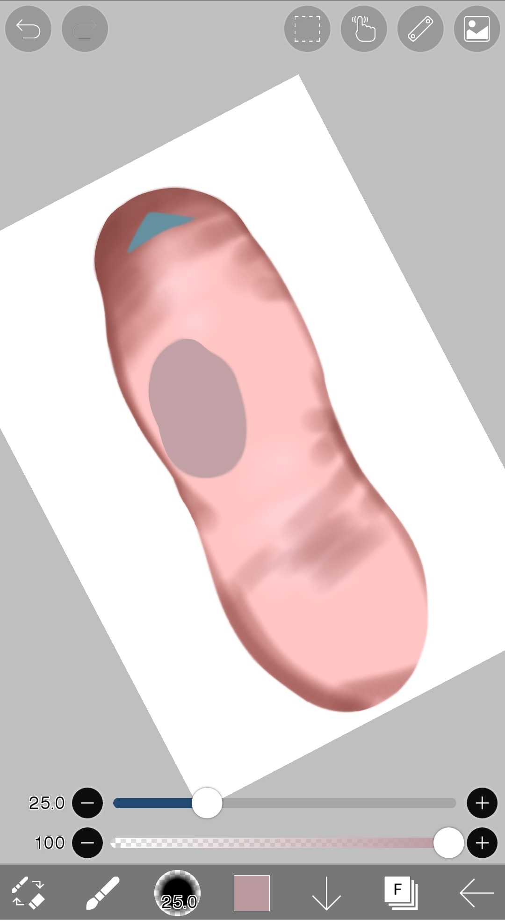

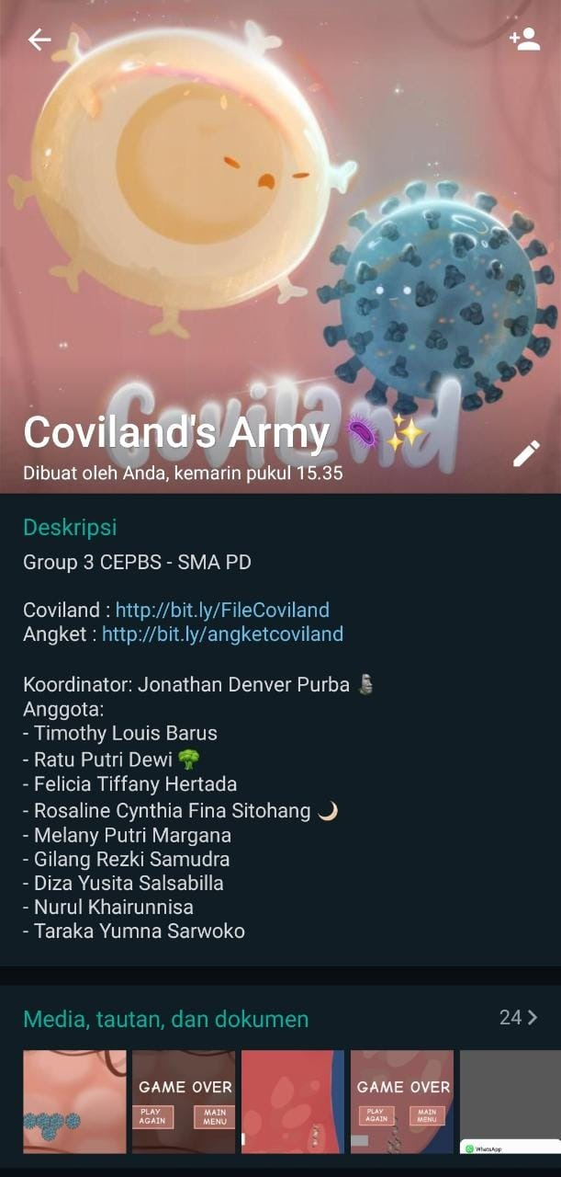

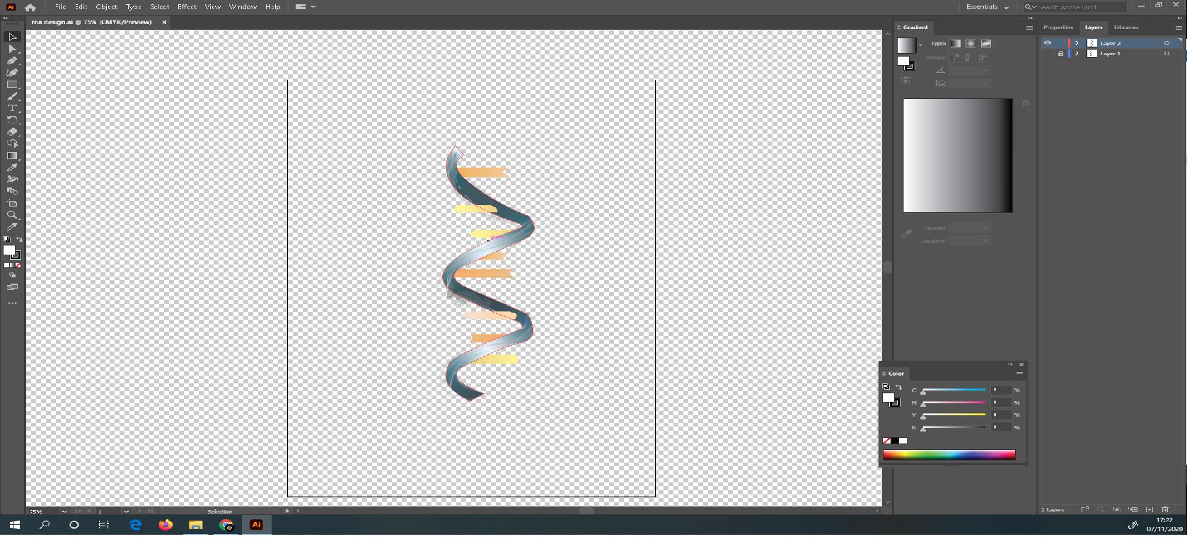

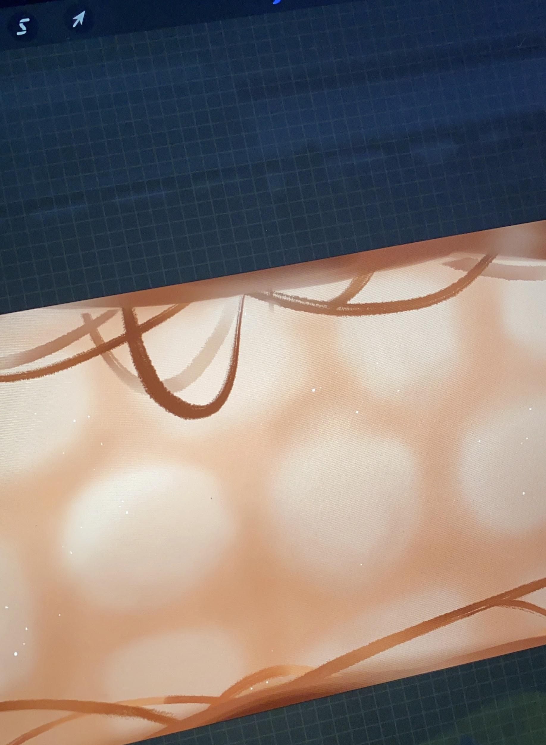 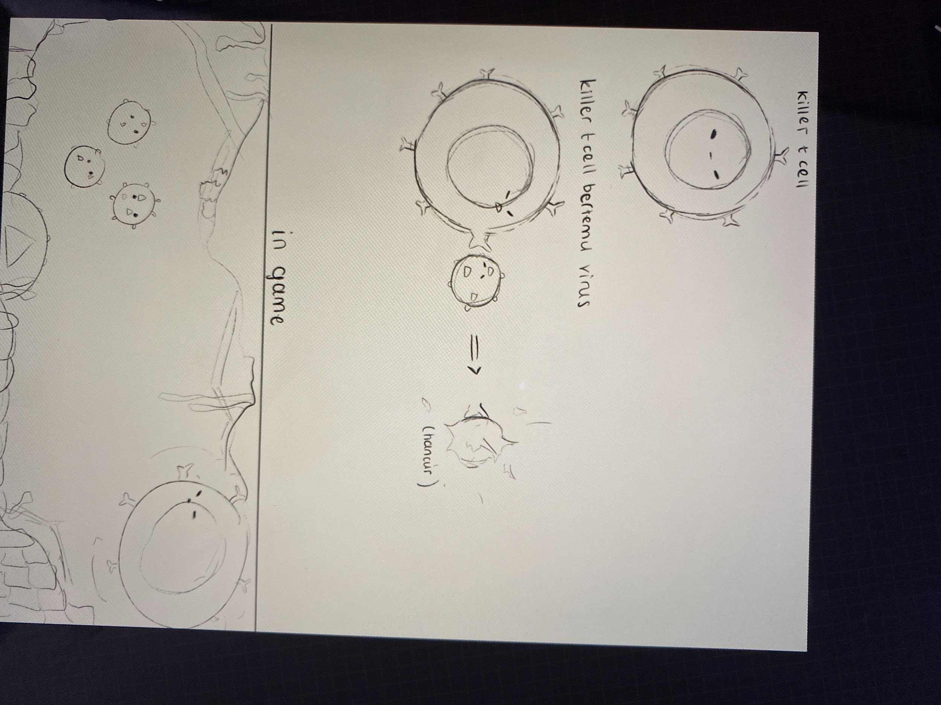

**ATTACHMENT 2. LIST OF ATTENDEES**

The attendees that participated in the trial of this game are as as follows:

|  |  |
| --- | --- |
| Judha | SMA Pradita Dirgantara, Boyolali |
| Trevor | SMA Pradita Dirgantara, Boyolali |
| La Reina | SMA 1 Mataram |
| Clara | SMA Pradita Dirgantara, Boyolali |
| Shabrina | SMA Pradita Dirgantara, Boyolali |
| Azka | SMA Pradita Dirgantara, Boyolali |
| Olivia | SMA Pradita Dirgantara, Boyolali |
| Aphrodity | SMA Pradita Dirgantara, Boyolali |
| Hekal | SMA Pradita Dirgantara, Boyolali |
| Stefy | SMP Negeri 4 Yogyakarta |
| Ahmad | SMA Pradita Dirgantara, Boyolali |
| Anggi | SMA Pradita Dirgantara, Boyolali |
| Lala | SMA 1 Yogyakarta |
| Audrey | SMA Pradita Dirgantara, Boyolali |
| Leyga | SMA Pradita Dirgantara, Boyolali |
| Radifan | SMA Pradita Dirgantara, Boyolali |
| Puput | SMA Pradita Dirgantara, Boyolali |
| Gabriel | SMA Pradita Dirgantara, Boyolali |
| Nintha | SMA Pradita Dirgantara, Boyolali |
| Matthew | SMA Negeri 2 Taruna Bhayangkara Jawa Timur |
| Aida | SMA Pradita Dirgantara, Boyolali |
| Ahmad Riza Yuwono | SMA Angkasa 2, Jakarta |
| Viera | SMA Pradita Dirgantara, Boyolali |
| Kyla | SMA Pradita Dirgantara, Boyolali |
| Afi | SMA Pradita Dirgantara, Boyolali |
| Hana | SMA Pradita Dirgantara, Boyolali |
| Duta | SMA Negeri 4 Semarang |
| Sakti | SMA Pradita Dirgantara, Boyolali |
| Jeje | SMA Pradita Dirgantara, Boyolali |
| Fatih | SMA Pradita Dirgantara, Boyolali |
| Muhammad Izam | SMAN 8 Yogyakarta |
| Muhammad Rizky Narindra | SMA Pradita Dirgantara, Boyolali |
| Kristin Kaskarini Hitdarto | SMA Pradita Dirgantara, Boyolali |
| Nasywa Atha | SMA Pradita Dirgantara, Boyolali |
| Qowim | SMAN 9 Malang |
| Vidya | SMA Negeri 1 Mataram |
| Zheannetta | SMA Pradita Dirgantara, Boyolali |
| Gerald | SMA Pradita Dirgantara, Boyolali |
| Salsabila | SMA Pradita Dirgantara, Boyolali |

**PROJECT BASED SERVICE REPORT**

**“INTRODUCING THE IMMUNE SYSTEM THROUGH GAMES”**

**SMA PRADITA DIRGANTARA 2020/2021**

|  |  |  |  |  |  |
| --- | --- | --- | --- | --- | --- |
| **No.** | **Name** | **Qt** | **Price** | **Budget Spent** | **Remainder** |
| 1. | Game Developer Service | 1 | Rp 2.000.000 | Rp 2.000.000 | Rp 0 |
| Total | | | | Rp 2.000.000 | Rp 0 |